Pokhara University

Level: Bachelor | Semester – Spring | Year : 2005
Programme: BE |  | Full Marks: 100
Course: Electrical Engineering Material |  | Time : 3hrs.

Candidates are required to give their answers in their own words as far as practicable.
The figures in the margin indicate full marks.

Attempt all the questions.

 | - Define density of state function. Obtain an expression for it to show that the number of available energy levels increases parabolically with increasing energy.  - Explain the term drift velocity and diffusion of electrons. | 10  5
 | - The room temperature electrical resistivity of copper is 1.69X 10⁻⁸ ohm – m. The concentration of electrons in copper is 8.5X²² per cm³. Calculate drift mobility, relaxation time of electron.  - Explain with example the conduction process in electrolytes. | 7  8
 | - The relative dielectric constant of a glass and that of plastics are 3.1 and 2.9 respectively. What distance should the electrodes having a potential difference of 40V are to be separated with glass, if we want same charge density, as would develop on another set of electrodes separated by 0.42 cm of plastic and 50v?  - Why ferrites are used for high frequency transformer? Explain the various properties of hard and soft magnetic materials with hysteresis loop. | 6  9
 | - How the macroscopic parameters are related to microscopic parameters in dielectric materials? Show.  - Define eddy "current losses", "domain structure" and explain shortly about hard magnetic materials. | 7  8
 | - What are the various methods of Diffusion? Explain ion implantation in detail.  OR  What do you understand by photolithography? Explain methods of crystal Growing in brie.  - Derive the Einstein relationship for holes and free electrons  OR  What happens when N-type of semiconductor is brought into contact with a P-type? Explain with diagram. | 8  7
 | - A semiconductor crystal is characterised by following energy band diagram at 300k.  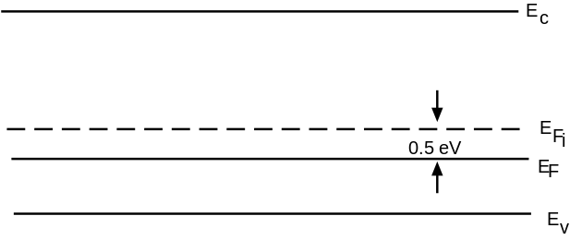  - Find the type of dopant and doping level.  - Calculate the conductivity of semiconductor at room.  - If it is desired that the Fermi-level is to be raised to 0.1 eV above intrinsic Fermi-level. What type of dopant is to be used? Determine its doping level.  - Explain the recombination process in a semiconductor with necessary diagrams. | 8  7
 | Write short notes on (Any Two):  - Silicon crystals growing  - Polarization  - Electron Hole Pairs  - Thermionic emission | 2x5

